PROJECT PHASE - II
MIND2APP
(USER BASED APP GENERATOR)

An Project Phase - I Report Submitted
In partial fulfillment of the requirements for the award of the degree of

Bachelor of Technology
in
Computer Science and Engineering
by

SUGANDAPU ANUSHA 22N31A05N4

SARPATWARI ATHARVA 22N31A05M0

REDDY RUCHITHA 23N35A0522

Under the esteemed guidance of
Mr.D.JAGADEESH
Assistant Professor



Department of Computer Science and Engineering
Malla Reddy College of Engineering & Technology
(Autonomous Institution- UGC, Govt. of India)
(Affiliated to JNTUH, Hyderabad, Approved by AICTE, NBA &NAAC with ‘A’ Grade)
Maisammaguda, Kompally, Dhulapally, Secunderabad – 500100
website: www.mrcet.ac.in
2022-2026

Malla Reddy College of Engineering & Technology
(Autonomous Institution- UGC, Govt. of India)
(Affiliated to JNTUH, Hyderabad, Approved by AICTE, NBA &NAAC with ‘A’ Grade)
Maisammaguda, Kompally, Dhulapally, Secunderabad – 500100
website: www.mrcet.ac.in

CERTIFICATE

This is to certify that this is the bonafide record of the project entitled “Honey Encryption(A Deceptive Security Approach)”, submitted by Sika Akshitha(22N31A05M9) , Thumkoju pravalika(22N31A05P6) and Undralla Sri Vardhan(22N31A05Q1) of B.Tech in the partial fulfillment of the requirements for the degree of Bachelor of Technology in Computer Science and Engineering, Department of CSE during the year 2025-2026. The results embodied in this project report have not been submitted to any other university or institute for the award of any degree or diploma.

Internal Guide Project Coordinator Head of the Department
Mrs.Amrutha Mary Dr.M.Sambasivudu Dr.G.Ravi
Assistant Professor Associate Professor Professor

External Examiner

DECLARATION

We here by declare that the Project Phase-1 report titled “Honey Encryption(A Deceptive Security Approach)” submitted to Malla Reddy College of Engineering and Technology (UGC Autonomous), affiliated to Jawaharlal Nehru Technological University Hyderabad (JNTUH) for the award of the degree of Bachelor of Technology in Computer Science and Engineering is a result of original research carried- out in this thesis. It is further declared that the project report or any part thereof has not been previously submitted to any University or Institute for the award of a degree.

SIKA AKSHITHA 22N31A05M9

THUMKOJU PRAVALIKA 22N31A05P6

UNDRALLA SRI VARDHAN 22N31A05Q1

ACKNOWLEDGEMENT
We feel honored to place our warm salutation to our college Malla Reddy College of Engineering and Technology (UGC-Autonomous) for giving us an opportunity to do this Project as part of our B.Tech Program. We are ever grateful to our Principal Dr.V.Murali Mohan who enabled us to have experience in engineering and gain profound technical knowledge.

We express our heartiest thanks to our HOD, Dr. G.Ravi for encouraging us in every aspect of our course and helping us realize our full potential.

We would like to thank our Project Guide, Mr.D.Jagadeesh for her regular guidance, suggestions and constant encouragement. We are extremely grateful to our Project Coordinator Dr.M.Sambasivudu for his continuous monitoring and unflinching co-operation throughout project work.

We would like to thank our Class Incharge ,Dr.M.Sambasivudu who in spite of being busy with his/her academic duties took time to guide and keep us on the correct path.

We would also like to thank all the faculty members and supporting staff of the Department of CSE and all other departments who have been helpful directly or indirectly in making our project a success.

We are extremely grateful to our parents for their blessings and prayers for the completion of our project that gave us strength to do our project.

With regards and gratitude

SIKA AKSHITHA 22N31A05M9

THUMKOJU PRAVALIKA 22N31A05P6

UNDRALLA SRI VARDHAN 22N31A05Q1

ABSTRACT

Mind2App is a web-based platform that helps users create mobile or web applications easily. In traditional software development, building an application requires programming knowledge, technical skills, and a lot of time. Because of this, many people with good ideas are not able to develop applications. Mind2App solves this problem by providing a simple and user-friendly platform where users can create applications without writing code. Users can choose interface components and set basic features by following simple steps. Based on the user’s inputs, the system automatically generates a working application that can also be previewed and tested. The main aim of Mind2App is to reduce development time and make application development easy for everyone, including people who do not know programming. This platform helps users quickly turn their ideas into real applications.

 | TABLE OF CONTENTS
S.NO | TITLE | PG.NO
1 | INTRODUCTION | 01
 | 1.1 PURPOSE AND OBJECTIVES | 02
 | 1.2 EXISTING AND PROPOSED SYSTEM | 03
 | 1.3 SCOPE OF PROJECT | 04
2 | LITERATURE SURVEY | 05
3 | SYSTEM ANALYSIS | 07
 | 2.1 HARDWARE AND SOFTWARE REQUIREMENTS | 07
 | 2.2 SOFTWARE REQUIREMENTS SPECIFICATION | 08
4 | SYSTEM DESIGN | 13
 | 3.1 ARCHITECTURE | 13
 | 3.2 UML DIAGRAMS | 14
5 | METHODOLOGY | 21
 | 4.1 MODULE DESCRIPTION | 21
 | 4.2 PROCESS/ALGORITHM | 22
6 | IMPLEMENTATION | 23
 | 5.1 SAMPLE CODE | 23
 | 5.2 OUTPUT SCREENS | 27
7 | CONCLUSION & FUTURE SCOPE | 32
8 | BIBLIOGRAPHY | 33

LIST OF FIGURES

FIGURE.NO | NAME | PG.NO
4.2 | SYSTEM FLOW DIAGRAM | 13
4.2.1 | CLASS DIAGRAM | 14
4.2.2 | SEQUENCE DIAGRAM | 15
4.2.3 | USE CASE DIAGRAM | 16
4.2.4 | ACTIVITY DIAGRAM | 17
4.2.5 | STATE CHART DIAGRAM | 18
4.2.6 | COLLABORATION DIAGRAM | 19
4.2.7 | COMPONENT DIAGRAM | 19
4.2.8 | DEPLOYMENT DIAGRAM | 20

LIST OF OUTPUTS

FIGURE.NO | NAME | PG.NO
6.2.1 | Home Page | 27
6.2.2 | Login Page | 28
6.2.3 | Encrypt Page | 29
6.2.4 | Dencrypt Page | 30
6.2.5 | Location Page | 31

1.INTRODUCTION

Mind2App is a web-based platform that helps users create mobile or web applications easily. Many people have good ideas for applications, but they cannot develop them because application development usually requires programming knowledge, technical skills, and a lot of time. Mind2App is designed to solve this problem by providing a simple platform where users can create applications without writing code.
The platform provides a user-friendly interface where users can select different components and add basic features by following simple steps. Based on the information given by the user, the system automatically generates a working application. Users can also preview and test the application to check how it works.
The main aim of Mind2App is to reduce development time and make application development easy for everyone. It helps people quickly turn their ideas into real applications, even if they do not have programming knowledge.

1.1 PURPOSE AND OBJECTIVES

PURPOSE

Running through the whole process of Mind2App is the idea of creating a very smart and automated system that can produce complete and working web applications out of the customer’s given data. This way the system wants to offer a straightforward and friendly solution for app-making instead of depending on tedious coding, high designing skills, andclassic development practices.

OBJECTIVES
- Provide a simple and user-friendly platform for non-technical users.
- Allow users to define application requirements easily.
- Automatically generate complete web applications.
- Integrate UI, navigation, and basic backend structure.
- Reduce application development time.
- Minimize dependency on professional developers.

1.2 EXISTING SYSTEM AND PROPOSED SYSTEM

EXISTING SYSTEM
In the existing system, developing a mobile or web application requires strong programming knowledge, technical skills, and a lot of development time. Developers must write code, design the user interface, and manage different tools and technologies to build an application. This process can be complex and difficult for people who do not have coding experience. Because of this, many individuals with creative ideas are unable to develop their own applications. The existing development process also takes more time for designing, testing, and deployment, which makes it less accessible for beginners and non-programmers.
.

PROPOSED SYSTEM

The proposed system introduces Mind2App, a web-based platform that simplifies the process of creating mobile and web applications. It allows users to develop applications without programming knowledge by providing a simple and user-friendly interface. Users can select interface components, add basic features, and design their application through easy steps. Based on the inputs given by the user, the system automatically generates a working application that can be previewed and tested. This system helps in reducing development time and makes application development accessible to everyone, including beginners and non-programmers, enabling them to easily convert their ideas into real applications.

1.3 SCOPE OF PROJECT
The scope of the Mind2App project is to simplify the process of mobile and web application development. It provides a web-based platform where users can create applications without having programming knowledge. The system allows users to select interface components, add features, and design applications using simple steps. It also enables users to generate, preview, and test applications based on their requirements. The main focus of this project is to reduce development time and make application creation easy and accessible for beginners and non-programmers.
In addition, the platform helps users to quickly convert their ideas into working applications without facing technical difficulties. It can be useful for students, small businesses, and individuals who want to develop applications easily. In the future, the system can be improved by adding more advanced tools, customization options, and support for different types of applications, which will make the platform more powerful and flexible for users.

- LITERATURE SURVEY

1.Low-Code / No-Code (LCNC) Development Platforms

Low-Code / No-Code (LCNC) development platforms allow users to create applications using visual tools like drag-and-drop interfaces, templates, and pre-built components. These platforms reduce the need for manual coding and help in faster application development. Users can easily design application layouts, add features, and manage workflows through simple graphical interfaces. LCNC platforms are widely used by businesses and developers for rapid prototyping and quick application development. They also help reduce development time and cost compared to traditional programming methods.

Limitations:
Requires some technical knowledge, limited customization, and not fully automated development.

2. Automated UI and Code Generation
Automated UI and Code Generation systems use model-driven approaches and AI techniques to automatically generate application interfaces and functional code. The system converts structured inputs such as requirements or data models into user interface layouts and backend code. This approach improves development speed, consistency, and reliability while reducing human effort in interface design and coding. Some systems also support blueprint or model-based planning, which helps in designing the application structure before generating the actual code.
Limitations:
Mostly focuses on UI generation, limited support for full application development, and may require manual coding for complex features.

3.SYSTEM ANALYSIS

3.1 SOFTWARE AND HARDWAREREQUIREMENTS

HARDWARE REQUIREMENTS
Minimum Requirements:
- Processor: Dual-core (Intel i3 or equivalent)
- RAM: 4 GB
- Storage: 5–10 GB free space
- Display: 720p resolution
- Internet: Stable connection

SOFTWARE REQUIREMENTS

Operating System: Windows / Linux / macOS

Programming Languages: Python, HTML, CSS, JavaScript

Framework: Flask (for backend development)

Web Browser: Google Chrome / Mozilla Firefox / Microsoft Edge

Code Editor / IDE: Visual Studio Code

Database: MongoDB or MySQL

3.2 SOFTWARE REQUIREMENTS SPECIFICATION

1. Introduction

1.1 Purpose

The purpose of this project is to develop Mind2App, a web-based platform that helps users create mobile or web applications easily without programming knowledge. The system is designed to simplify the application development process by providing a user-friendly environment where users can select components, add features, and generate applications automatically. It helps reduce the complexity of coding and allows users to quickly convert their ideas into working applications.

1.2 Scope

The scope of the Mind2App system is to provide a simple platform for designing and generating applications through guided steps. The system allows users to choose interface components, define basic functionalities, and preview the generated application. It mainly focuses on reducing development time and making application creation accessible to beginners and non-programmers. In the future, the system can be extended with more advanced features, customization options, and support for different types of applications.

1.3 Definitions, Acronyms, and Abbreviations

UI: User Interface
API: Application Programming Interface
LCNC: Low-Code / No-Code
DB: Database
IDE: Integrated Development Environment
OS: Operating System
HTML: HyperText Markup Language
CSS: Cascading Style Sheets
JS: JavaScript
SRS: Software Requirements Specification

1.4 References
Pressman, R. S., Software Engineering, McGraw-Hill.
Sommerville, I., Software Engineering, Pearson.
W3Schools – Web Development Tutorials.
Python Official Documentation.

2. Functional Requirements

2.1 User Registration

The system should allow new users to create an account.

The system should store user details securely.

2.2 User Login

The system should allow registered users to log in.

The system should verify the username and password.

2.3 Application Creation

The system should allow users to create a new application.

Users should be able to enter application details.

2.4 Component Selection

The system should allow users to select interface components.

Users should be able to add or remove UI elements.

2.5 Preview and Testing

The system should allow users to preview the generated application.

Users should be able to test the application features.

3. Non-Functional Requirements

3.1 Performance
The system should respond to user actions quickly.
The application should load pages within a few seconds.
3.2 Security
The system should protect user data and login information.
The system should allow only authorized users to access the platform.
3.3 Usability
The system should provide a simple and user-friendly interface.
The system should be easy to use for beginners and non-programmers.
3.4 Reliability
The system should work properly without frequent failures.
The system should ensure stable performance during usage.
3.5 Scalability
The system should support multiple users at the same time.
The system should handle increasing data and users in the future.

4. System Design Constraints

4.1 Technologies

Programming Languages: Python, HTML, CSS, JavaScript

Framework: Flask for backend development

Database: MongoDB or MySQL for data storage

Development Tool: Visual Studio Code (IDE)

Web Browser: Google Chrome or Mozilla Firefox for testing and running the application

4.2 Hardware and Integration
Processor: Intel Core i3 or higher
RAM: Minimum 4 GB
Storage: 500 GB Hard Disk
Network: Stable Internet Connection
Integration: Cloud storage or database (MongoDB / MySQL) for storing user and application data.

5. Appendices

5.1 Glossary

Mind2App: A web-based platform used to create mobile or web applications without coding.

User Interface (UI): The visual part of the system that allows users to interact with the

application.

Low-Code / No-Code (LCNC): A development method that allows users to buil

applications with minimal or no programming.

Application Generation: The process of automatically creating an application based on user inputs.

Database: A system used to store and manage user and application data.

5.2 References
Pressman, R. S., Software Engineering, McGraw-Hill.
Sommerville, I., Software Engineering, Pearson.
W3Schools – Web Development Tutorials.
Python Official Documentation.

4.SYSTEM DESIGN

4.1 ARCHITECTURE

Fig:4.1Architecture

The architecture diagram represents the overall structure of the system and shows how different components of the application interact with each other. It explains how the data flows from the user to the system and how the system processes that data to produce the final output. In this architecture, the process begins with the user interface, where the user provides inputs such as the application name, tagline, and required pages. The input is then sent to the input processing module, which validates and organizes the data. After that, the blueprint generator creates the basic structure and navigation flow of the application. The template management module selects suitable UI templates to maintain a consistent design. Next, the code generation module automatically generates the required application code based on the blueprint and templates. Finally, the system produces the generated application as output, which the user can view and use. Thus, the architecture diagram helps in understanding how the system components work together to convert user input into a complete application.

4.2 UML DIAGRAM

4.2.1 CLASS DIAGRAM:

4.2.1 Class Diagram

The Class Diagram shows the structure of the system by representing different classes, their attributes, methods, and relationships. In this system, classes like UserInput, BlueprintGenerator, TemplateManager, CodeGenerator, and GeneratedApp are used. The UserInput class collects details from the user such as app name and selected pages. The BlueprintGenerator creates the application structure. The TemplateManager provides suitable UI templates, and the CodeGenerator generates the application code. Finally, the GeneratedApp represents the final output of the system.

4.2.2 SEQUENCE DIAGRAM:

Fig:4.2.2 sequence diagram

The Sequence Diagram shows how different components of the system interact with each other in a step-by-step process over time. It explains the order in which messages are exchanged between the User, User Interface, Input Processor, Blueprint Generator, and App Generator. First, the user enters the app details through the user interface. The Input Processor then validates the entered information to ensure it is correct. After validation, the Blueprint Generator creates the structure or blueprint of the application. Next, the App Generator generates the application code based on the blueprint. Finally, the generated app is returned to the user interface and displayed to the user. This diagram helps in understanding how the system processes user input and generates the final application step by step.

4.2.3 USECASE DIAGRAM:

Fig:4.2.3 Use Case Diagram

The Use Case Diagram represents how the user interacts with the Mind2App system and shows the main functions performed by the system. In this diagram, the User acts as the main actor who interacts with the application. The user provides the required details such as the app name, tagline, and selected pages through the system interface. After receiving the input, the system performs different actions like processing the input, generating the application blueprint, and creating the application code. Finally, the system generates the complete application and displays it to the user. The use case diagram helps to clearly show the relationship between the user and the main functionalities of the system in a simple way.

4.2.4 ACTIVITY DIAGRAM:

Fig:4.2.4 activity diagram
The Activity Diagram represents the workflow of the Mind2App system and shows the sequence of activities performed to generate an application. The process starts when the user enters the application details such as the app name, tagline, and required pages. The system then validates and processes the input to ensure that the provided information is correct. After validation, the system creates a blueprint or structure of the application, which defines the layout and navigation of the app. Next, the app generator automatically generates the application code based on the blueprint. Finally, the generated application is displayed to the user. The activity diagram helps in understanding the step-by-step flow of the system from user input to the final generated application.

4.2.5 STATECHART DIAGRAM

Fig:4.2.5 State Chart Diagram
The State Chart Diagram shows the different states of the Mind2App system and how the system changes from one state to another during the app generation process. The process begins with the initial state, where the system waits for the user to enter the application details. Once the user provides the details, the system moves to the input validation state, where the entered information is checked. After successful validation, the system enters the blueprint creation state, where the structure of the application is generated. Next, the system moves to the code generation state, where the application code is automatically created. Finally, the system reaches the output state, where the generated application is displayed to the user. This diagram helps to understand how the system changes its state step by step during the app creation process.

4.2.6 COLLABORATION DIAGRAM

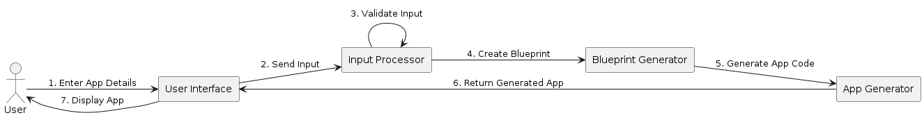

Fig:4.2.6 collaboration diagram

The Collaboration Diagram (Communication Diagram) shows how different components of the system interact with each other to generate the application. In this diagram, the User first enters the application details through the User Interface. The user interface sends the input data to the Input Processor, where the information is validated. After validation, the Blueprint Generator creates the basic structure of the application. Then the App Generator generates the application code based on the blueprint. Finally, the generated application is sent back to the User Interface and displayed to the User. This diagram helps to understand how system components communicate and work together to produce the final application.

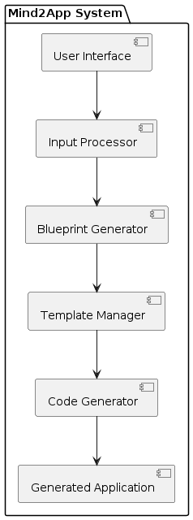
4.2.7 COMPONENT DIAGRAM

Fig:4.2.7component diagram

The Component Diagram shows the major components of the Mind2App system and how they are connected. The User Interface collects details from the user such as app name and pages. The Input Processor validates and processes the input data. The Blueprint Generator creates the structure of the application. The Template Manager provides suitable UI templates for the app design. The Code Generator generates the application code, and finally the Generated Application is produced as the output.

4.2.8 DEPLOYMENT DIAGRAM

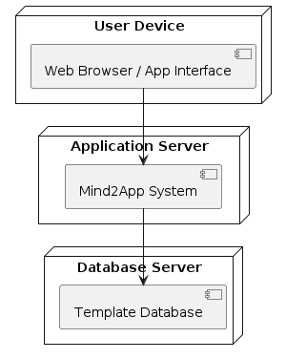
Fig:4.2.8 deployment diagram

The Deployment Diagram shows how the system is physically deployed on different hardware nodes. The User Device contains the web browser or application interface used by the user to enter app details. The request is sent to the Application Server, where the Mind2App system processes the input and generates the application. The system also communicates with the Database Server, which stores templates and related data. Finally, the generated application is returned to the user device.

5.METHODOLGY

5.1 MODULE DESCRIPTION
1.User Input Module
Collects app name, tagline, and page selections.
Stores user input in structured format.
2.Input Processing Module
Validates mandatory fields and checks errors.
Converts input into internal data structure.
3.Blueprint Generator Module
Creates application structure and page flow.
Defines navigation and required UI components.
4.Template Management Module
Loads predefined UI templates.
Ensures consistent layout and design.
5.Code Generation Module
Generates Flutter code automatically.
Builds complete application with navigation.
6.State Management Module
Manages dynamic data like products and cart.
Updates UI when data changes.
7.Output Module
Renders the generated application.
Provides ready-to-use final output.

5.2 PROCESS/ALGORITHM

Step 1: Open Application

User launches the Mind2App system.

Step 2: Enter Application Details

User enters application name and tagline.

Step 3: Select Required Pages

User selects pages like Home, Login, Product, Cart, etc.

Step 4: Input Validation

System validates the entered details and page selection.

Step 5: Blueprint Generation

System creates the internal structure and navigation plan.

Step 6: Template Loading

System loads predefined UI templates for selected pages.

Step 7: Code Generation

Flutter code is automatically generated based on the blueprint.

Step 8: Application Rendering

System builds and renders the complete application.

Step 9: Final Output

Ready-to-use application is displayed to the user.

User can test, modify, or deploy the generated app.

ALGORITHM
• Start
• Input the app name, tagline, and required pages from the user.
• Validate the entered input details.
• Check whether the input is valid or invalid.
• If invalid, request the user to enter the details again.
• If valid, generate the application blueprint.
• Load suitable UI templates for the selected pages.
• Generate the application code automatically.
• Build the application based on the generated code.
• Display the generated application to the user.
• End.

6.IMPLEMENTATION

6.1 SAMPLE CODE
Server.ts
import express from "express";
import { createServer as createViteServer } from "vite";
import cors from "cors";
import jwt from "jsonwebtoken";
import bcrypt from "bcryptjs";
import sqliteDb from "./src/lib/db";
import { encrypt, decrypt, DataType } from "./src/lib/honey-encryption";
import dotenv from "dotenv";

dotenv.config();

const app = express();
const PORT = 3000;
const JWT_SECRET = process.env.JWT_SECRET || "honey-shield-secret";

app.use(cors());
app.use(express.json());

// Middleware for auth
const authenticateToken = (req: any, res: any, next: any) => {
const authHeader = req.headers['authorization'];
const token = authHeader && authHeader.split(' ')[1];

if (!token) return res.sendStatus(401);

jwt.verify(token, JWT_SECRET, (err: any, user: any) => {
if (err) return res.sendStatus(403);
req.user = user;
next();
});
};

// --- Auth Routes ---

app.post("/api/register", async (req, res) => {
const { username, email, password } = req.body;
try {
const hashedPassword = await bcrypt.hash(password, 10);
const stmt = sqliteDb.prepare("INSERT INTO users (username, email, password_hash) VALUES (?, ?, ?)");
stmt.run(username, email, hashedPassword);
res.status(201).json({ message: "User registered successfully" });
} catch (err: any) {
res.status(400).json({ error: "Username or email already exists" });
}
});

app.post("/api/login", async (req, res) => {
const { username, password } = req.body;
const user: any = sqliteDb.prepare("SELECT * FROM users WHERE username = ?").get(username);

if (!user || !(await bcrypt.compare(password, user.password_hash))) {
return res.status(401).json({ error: "Invalid credentials" });
}

const token = jwt.sign({ id: user.id, username: user.username, role: user.role }, JWT_SECRET);
res.json({ token, user: { id: user.id, username: user.username, role: user.role } });
});

// --- Vault Routes ---

app.post("/api/vault/encrypt", authenticateToken, (req: any, res) => {
const { title, data, key, type } = req.body;
const ciphertext = encrypt(data, key);

const stmt = sqliteDb.prepare("INSERT INTO vault_items (user_id, title, ciphertext, data_type) VALUES (?, ?, ?, ?)");
stmt.run(req.user.id, title, ciphertext, type);
res.json({ message: "Data encrypted and stored" });
});
app.get("/api/vault", authenticateToken, (req: any, res) => {
const items = sqliteDb.prepare("SELECT id, title, data_type, created_at FROM vault_items WHERE user_id = ?").all(req.user.id);
res.json(items);
});
app.post("/api/vault/decrypt", authenticateToken, (req: any, res) => {
const { id, key } = req.body;
const item: any = sqliteDb.prepare("SELECT * FROM vault_items WHERE id = ? AND user_id = ?").get(id, req.user.id);
if (!item) return res.status(404).json({ error: "Item not found" })
const { data, isHoney } = decrypt(item.ciphertext, key, item.data_type as DataType);
// Log the attempt
const status = isHoney ? 'honey_triggered' : 'success';
const logStmt = sqliteDb.prepare("INSERT INTO logs (user_id, action, status, details) VALUES (?, ?, ?, ?)");
logStmt.run(req.user.id, 'decryption', status, `Item ID: ${id}, Title: ${item.title}`);
res.json({ data, isHoney });
});
// --- Admin Routes ---
app.get("/api/admin/logs", authenticateToken, (req: any, res) => {
if (req.user.role !== 'admin') return res.sendStatus(403);
const logs = sqliteDb.prepare(`
SELECT l.*, u.username
FROM logs l
JOIN users u ON l.user_id = u.id
ORDER BY l.created_at DESC
LIMIT 100
`).all();
res.json(logs);
});
app.get("/api/admin/analytics", authenticateToken, (req: any, res) => {
if (req.user.role !== 'admin') return res.sendStatus(403);
const totalAttempts = sqliteDb.prepare("SELECT COUNT(*) as count FROM logs").get() as any;
const honeyTriggers = sqliteDb.prepare("SELECT COUNT(*) as count FROM logs WHERE status = 'honey_triggered'").get() as any;
const successAttempts = sqliteDb.prepare("SELECT COUNT(*) as count FROM logs WHERE status = 'success'").get() as any;
res.json({
totalAttempts: totalAttempts.count,
honeyTriggers: honeyTriggers.count,
successAttempts: successAttempts.count
});
});
// --- Vite Integration ---
async function startServer() {
if (process.env.NODE_ENV !== "production") {
const vite = await createViteServer({
server: { middlewareMode: true },
appType: "spa",
});
app.use(vite.middlewares);
} else {
app.use(express.static("dist"));
}
app.listen(PORT, "0.0.0.0", () => {
console.log(`Server running on http://localhost:${PORT}`);
});
}
startServer();

6.2 OUTPUT SCREENS

6.2.1 HomePage
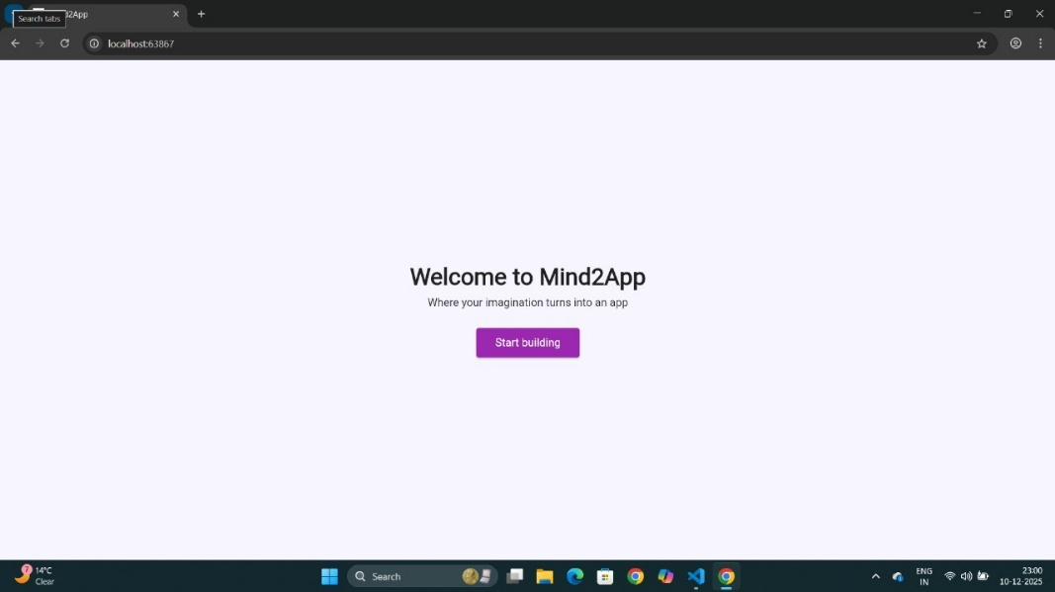

Fig:6.2.1 HomePage

The output screen displays the HoneyShield homepage, a security platform designed to protect data using Honey Encryption. The page features a dark-themed interface with the heading “Protect your data with Honey Encryption.” It explains that HoneyShield not only encrypts data but also generates fake outputs for incorrect keys to prevent brute-force attacks. Users can start using the system through options like “Create Secure Vault” or learn more via “How it Works.”

6.2.2 Login Page

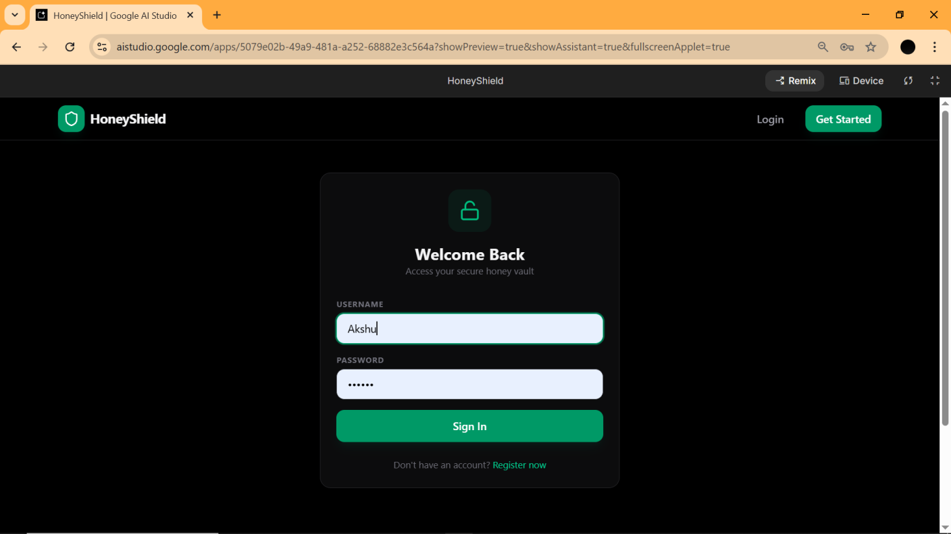

Fig:6.2.2 Login Page
The image shows a sleek, modern login interface for a web application called HoneyShield. Designed with a "dark mode" aesthetic, the page features a central authentication card with a green-and-white color scheme and a secure "honey vault" theme. The UI includes input fields for a username (filled as "Akshu") and a masked password, anchored by a prominent green "Sign In" button. The screenshot is captured within a browser tab showing suggesting this is a preview of a project currently under development.

6.2.3 Encrypt Page

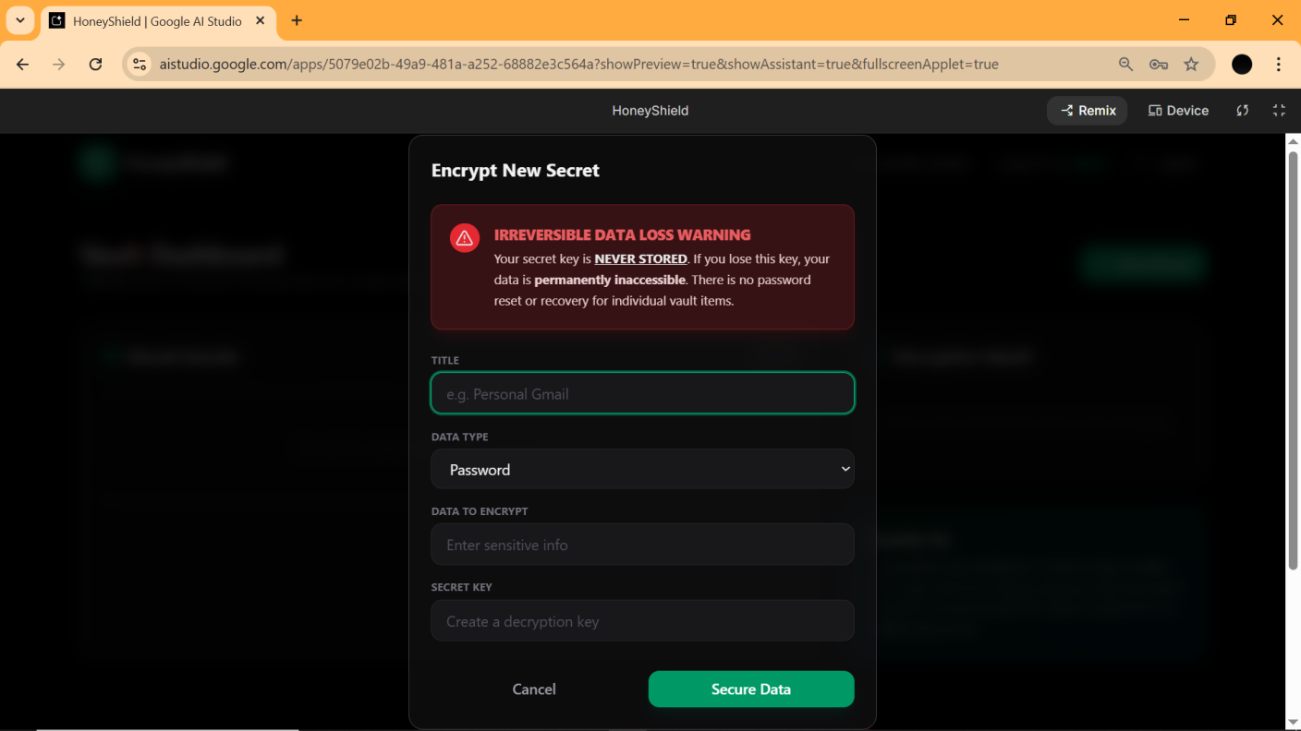

Fig:6.2.3 Encrypt Page
The provided screenshot showcases a user interface for the HoneyShield web application, specifically the "Encrypt New Secret" modal window. The UI features a high-contrast dark theme with a critical "Irreversible Data Loss Warning" displayed in red, informing users that secret keys are never stored and lost data is permanently inaccessible. Below this warning, the form includes input fields for a Title, a dropdown for Data Type (currently set to "Password"), a section for the Data to Encrypt, and a field to create a Secret Key. The interface is being previewed within Google AI Studio, reflecting an active development environment for this secure data vault application.

6.2.4 Dencrypt Page
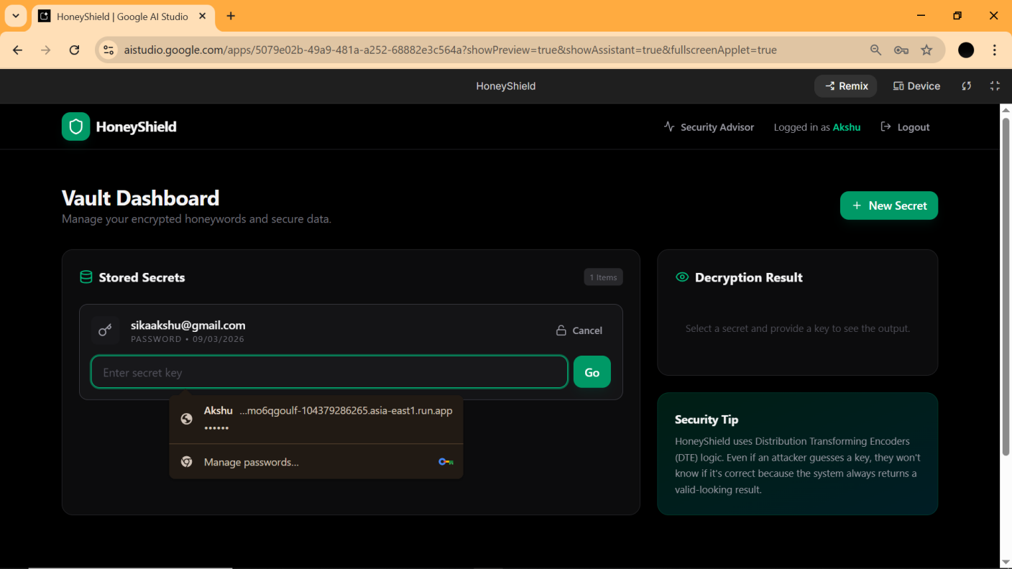
Fig 6.2.4 Dencrypt Page
The HoneyShield application, as seen in the screenshots, is a secure "honey vault" designed for encrypted data management. It features a sleek dark-mode interface that includes a "Welcome Back" login page and a "Vault Dashboard" where users like "Akshu" can manage stored secrets. A critical "Encrypt New Secret" modal warns that data loss is irreversible because secret keys are never stored. Notably, the system uses Distribution Transforming Encoders (DTE) logic to mislead attackers by returning valid-looking results even if an incorrect key is entered.

6.2.5 Location Page

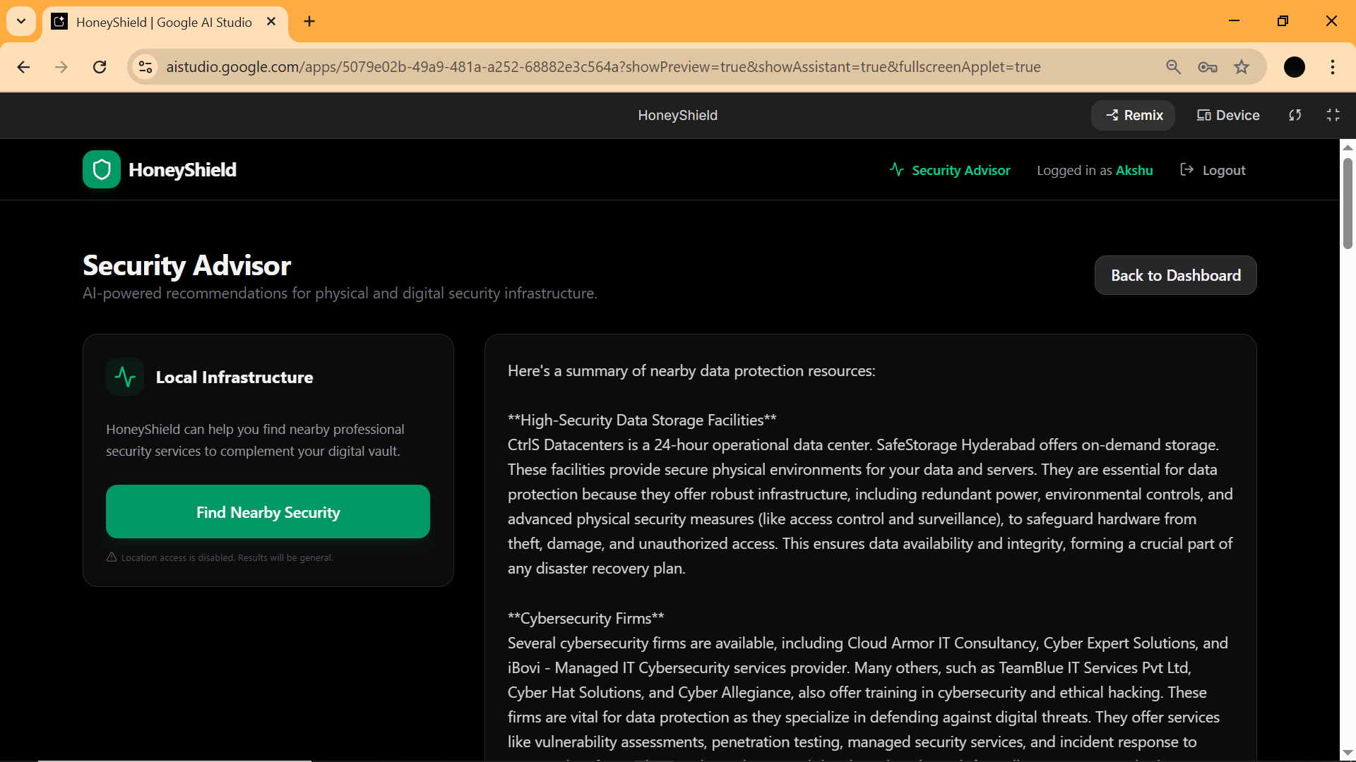

6.2.5 Location Page

The HoneyShield application is a secure "honey vault" designed to manage encrypted data through a sleek, dark-themed interface. Its core functionality includes an "Encrypt New Secret" feature that enforces a strict security policy where secret keys are never stored, meaning data becomes permanently inaccessible if a key is lost. The Vault Dashboard allows users to manage stored secrets and utilizes Distribution Transforming Encoders (DTE) logic, a defensive measure that always returns a valid-looking result to mislead potential attackers. Additionally, the platform features an AI-powered Security Advisor that provides recommendations for physical and digital protection, such as high-security data centers and cybersecurity firms.

7.CONCLUSION & FUTURE SCOPE

Conclusion

Honey Encryption is an advanced cryptographic technique that improves data security by protecting systems from brute-force and guessing attacks. Instead of revealing whether a key is correct or incorrect, it produces realistic-looking fake outputs for wrong keys, making it extremely difficult for attackers to identify the correct data. By using a Distribution-Transforming Encoder (DTE), every decryption attempt generates believable results. This approach adds an extra layer of security, especially for systems that depend on user-generated passwords or weak keys, and demonstrates the effectiveness of deception-based security in modern cybersecurity applications.

Future Scope

Future enhancements can focus on expanding support for multiple data types, including structured information such as financial records, medical data, and identity credentials. Developing a Graphical User Interface (GUI) or web-based dashboard will improve usability for non-technical users. The system can also be integrated into DevSecOps and CI/CD pipelines to protect sensitive configuration files, API keys, and secrets in development environments. Additional research may include performance benchmarking with modern and post-quantum cryptographic algorithms, improving the realism of decoy outputs, optimizing encryption speed, and building an open-source ecosystem to encourage collaboration and continuous security improvements.

8.BIBLIOGRAPHY

- Websites
- https://en.wikipedia.org/wiki/Honey_encryption
- https://www.crypto101.io/
- https://github.com/torjusbr/bip39-honey-encryption
- https://crypto.stanford.edu/
- https://owasp.org/www-project-honeypot/
- https://dl.acm.org/
- https://www.schneier.com/blog/archives/2013/05/honeywords.html
- Books
- Cryptography Engineering: Design Principles and Practical Applications" by Bruce Schneier, Niels Ferguson.
- The Code Book: The Science of Secrecy from Ancient Egypt to Quantum Cryptography" by Simon Singh.
- Security Engineering: A Guide to Building Dependable Distributed Systems" by Ross J. Anderson.
- Applied Cryptography: Protocols, Algorithms, and Source Code in C" by Bruce Schneier.

